**Primary Sedimentation tank**

**Purpose:**

1- Removal of 40 - 60 % of suspended solids   
2- Removal of 25 - 35 % of B.O.D.   
3- Sediment the organic and inorganic matters to improve the properties of the sewage and prepare it for the biological treatment.

**Types of primary sedimentation tanks:**

1- Rectangular tank.

2- Circular tank.

**Factors affecting sedimentation efficiency:**

1- Viscosity   
2- Concentration of suspended solids   
3- Retention period   
4- Horizontal velocity   
5- Temperature   
6- Surface loading rate = 24 - 48 m³/m²/day

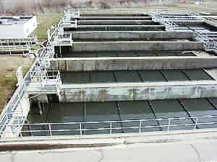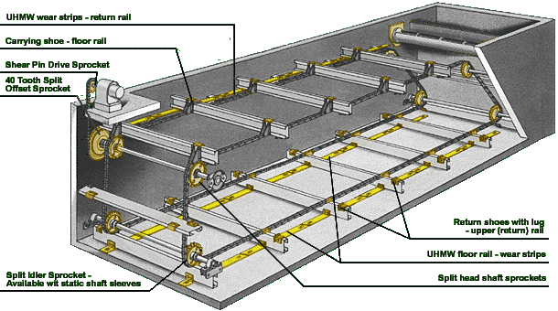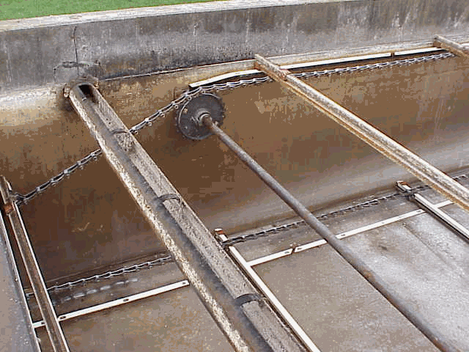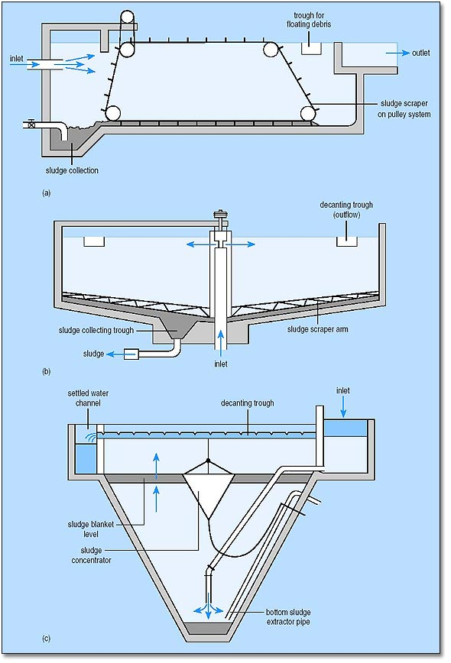

Primary sedimentation tank

(horizontal flow)



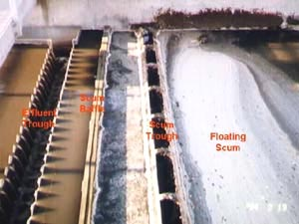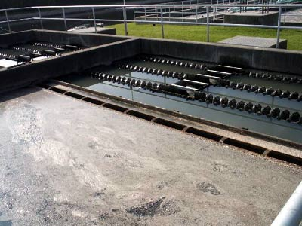

Effluent weir of rectangular sedimentation tank

Rectangular primary sedimentation tank

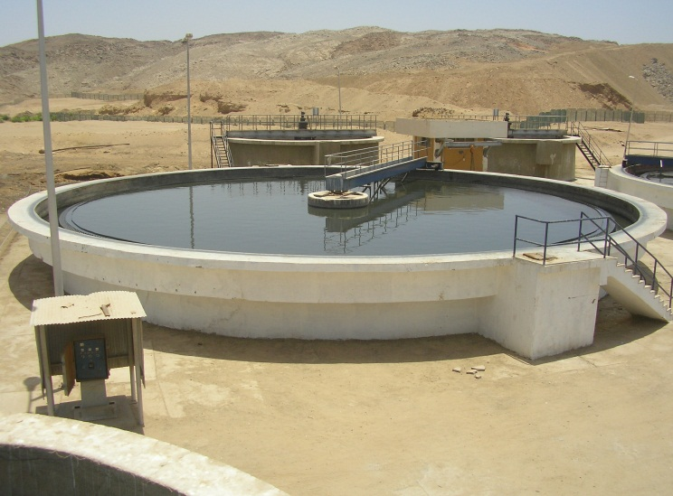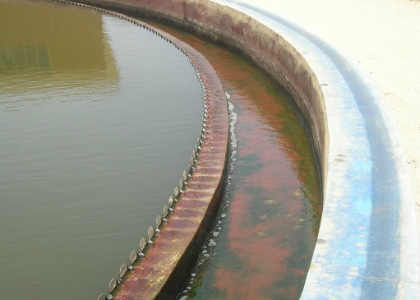

Primary sedimentation tank

(Radial flow)



Circular primary sedimentation tank

7- Dimension of tank   
8- Dead zones.

**Design criteria:**1- Retention period = T = 2 - 3 hrs   
2- Surface loading rate (S.L.R.) = 24 - 48 m³/m²/day   
3- Horizontal velocity ≤ 0.3 m/min   
4- Effluent weir loading (E.W.L.) ≤ 600 m³/m/day (≤ 25 m³/m/hr)   
5- L = 3 – 5 B

L ≤ 40 m   
6- d = 3 - 5 m   
7- B = 2 – 3 d

8- Φ ≤ 40 m  
9- Bottom slope for circular tank = 4 - 10 %

for rectangular tank = 1 - 2 %

V = Qd x T

S.L.R = Qd / S.A

**Example:**

For a sewage treatment plant, the following data are given:

- Qave summer = 18000 m3/d

- S.L.R = 30 m3/m2/d

It is required to design primary sedimentation tanks.

**Solution:**

Qd = 1.5 x 18000 = 27000 m3/d

**For rectangular tank:**

Assume T = 2.5 hr



≤L/7

≤L/7



**Circular primary sedimentation tank:**



**Example:**

Estimate the volume of sludge produced per 27000 m3/d if the influent S.S 300 mg/l. The removal efficiency is 60%.

**Solution:**



**For circular tank:**

